**How to install the java software**

**Step 1)** Go to [link](https://www.oracle.com/java/technologies/javase-downloads.html). Click on Download JDK. For java latest version.

[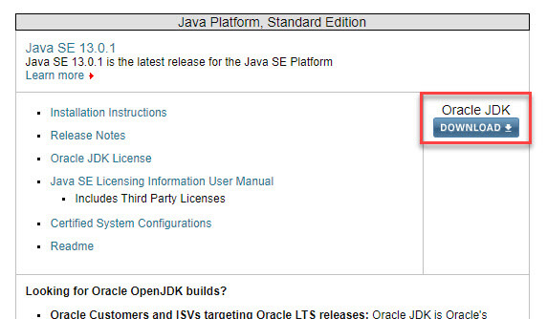](https://www.guru99.com/images/java/1912211_install_javaimage1.jpg)

**Step 2)** Next,

1. Accept License Agreement
2. Download latest Java JDK for your version(32 or 64 bit) of java for Windows.

[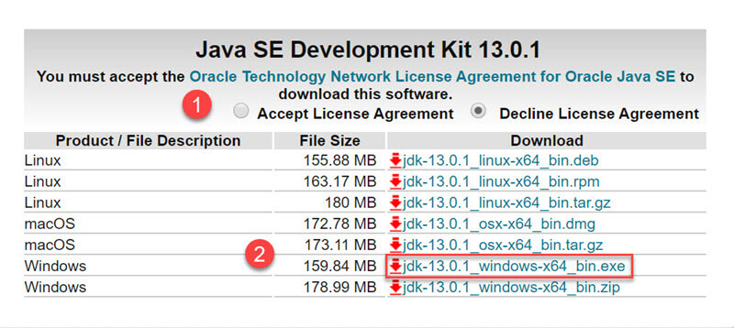](https://www.guru99.com/images/java/1912211_install_javaimage2.jpg)

**Step 3)** Once the download is complete, run the exe for install JDK. Click Next

[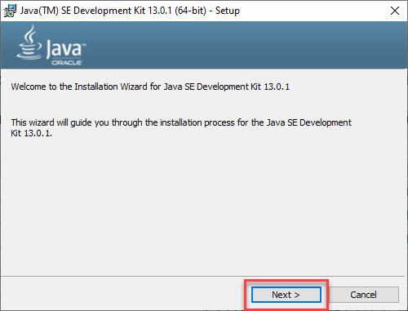](https://www.guru99.com/images/java/1912211_install_javaimage3.jpg)

**Step 4)** Select the PATH for Java installation and click next.

[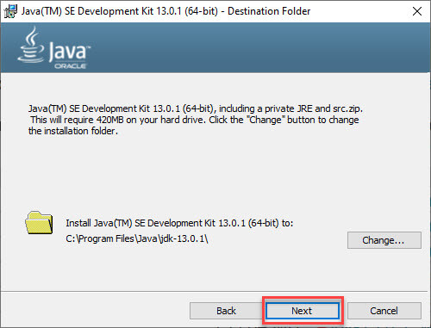](https://www.guru99.com/images/java/1912211_install_javaimage4.jpg)

**Step 5)** Once installation is complete click Close

[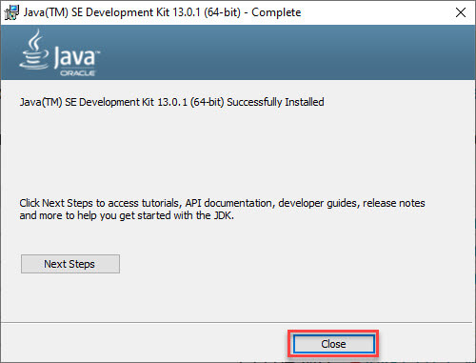](https://www.guru99.com/images/java/1912211_install_javaimage5.jpg)

**How to set Environment Variables in Java: Path and Class path**

The PATH variable gives the location of executables like javac, java etc. It is possible to run a program without specifying the PATH but you will need to give full path of executable like **C:\Program Files\Java\jdk-13.0.1\bin\javac A.java** instead of simple **javac A.java**

The CLASSPATH variable gives location of the Library Files.

Let's look into the steps to set the PATH and CLASSPATH

**Step 1)** Right Click on the My Computer and Select the properties

[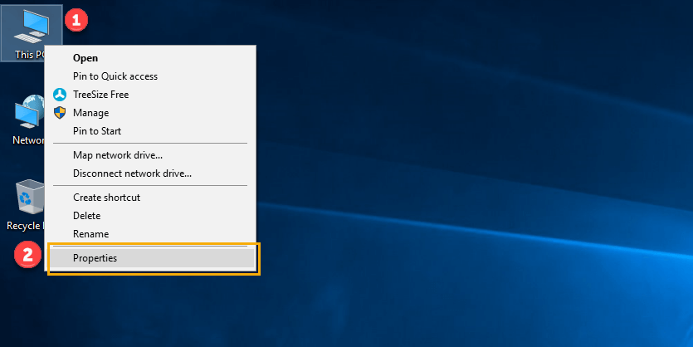](https://www.guru99.com/images/java/111417_1107_Java25.png)

**Step 2)** Click on advanced system settings

[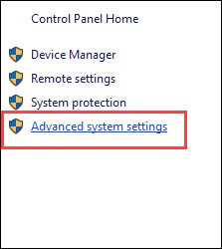](https://www.guru99.com/images/java/111417_1107_Java26.png)

**Step 3)** Click on Environment Variables

[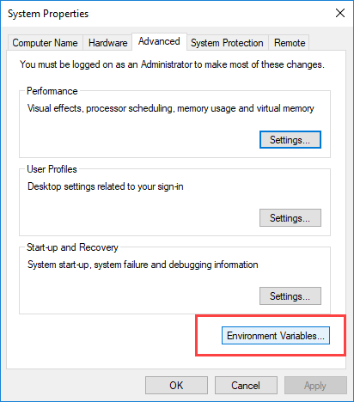](https://www.guru99.com/images/java/111417_1107_Java27.png)

**Step 4)** Click on new Button of User variables

[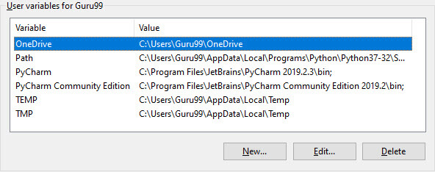](https://www.guru99.com/images/java/1912211_install_javaimage9.jpg)

**Step 5)** Type PATH in the Variable name.

[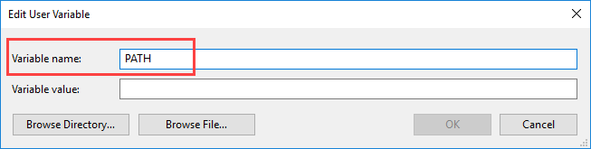](https://www.guru99.com/images/java/111417_1107_Java29.png)

**Step 6)** Copy the path of bin folder which is installed in JDK folder.

[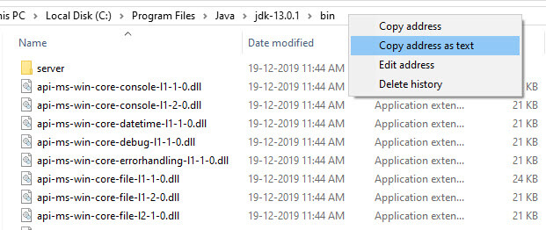](https://www.guru99.com/images/java/1912211_install_javaimage11.jpg)

**Step 7)** Paste Path of bin folder in Variable value and click on OK Button.

[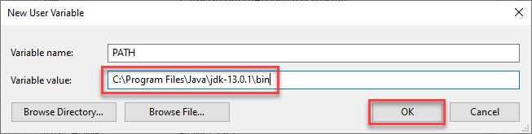](https://www.guru99.com/images/java/1912211_install_javaimage12.jpg)

**Note:** In case you already have a PATH variable created in your PC, edit the PATH variable to

PATH = <JDK installation directory>\bin;%PATH%;

Here, %PATH% appends the existing path variable to our new value

**Step 8)**You can follow a similar process to set CLASSPATH.

[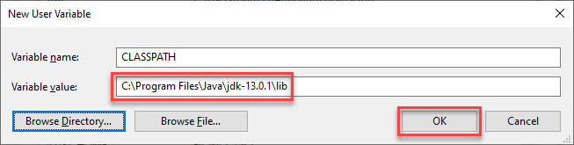](https://www.guru99.com/images/java/1912211_install_javaimage13.jpg)

**Note:** In case you java installation does not work after installation, change classpath to

CLASSPATH = <JDK installation directory>\lib\tools.jar;

**Step 9)** Click on OK button

[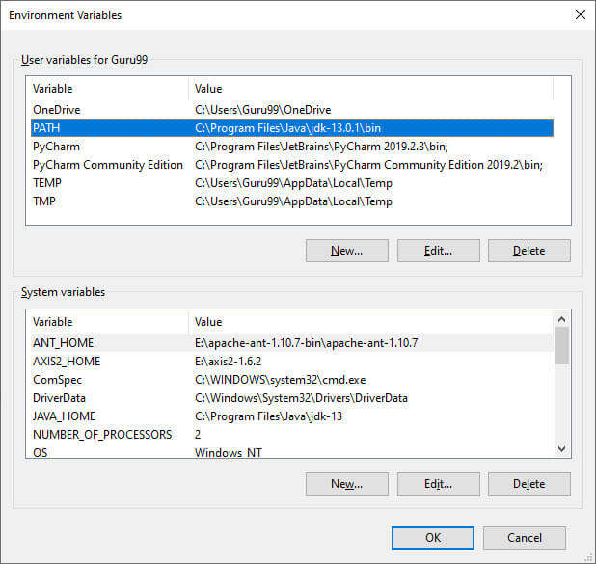](https://www.guru99.com/images/java/1912211_install_javaimage14.jpg)

**Step 10)** Go to command prompt and type javac commands.

If you see a screen like below, Java is installed.

[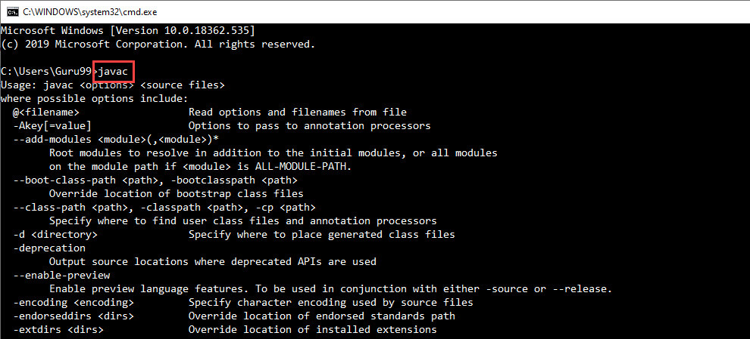](https://www.guru99.com/images/java/1912211_install_javaimage15.jpg)